Master thesis plan

**Department of Data Science and Knowledge Engineering  
Board of Examiners**

# Personal Details

Name: *(Student’s family name and first names)*    
Garcia Perez, Marina Sofia

Student number: *(Student’s ID number as provided by university)*   
i6179915

Program: *(Choose the master program that applies to this thesis)* Master Artificial Intelligence  
 Master Data Science for Decision Making

Start date of thesis research  
1st September 2019

Expected graduation date: *(Expected date when the thesis will be finished)*  
31st January 2020

# Supervision details

*There should be two thesis examiners that approve of this thesis plan. At least one of the examiners acts as a thesis supervisor. The examiners must be DKE staff members with a PhD degree.*

Name proposed thesis examiner 1: Signature:

Rico Möckel ………………………………………………

Name proposed thesis examiner 2: Signature:

Alexia Briassouli ………………………………………………

*The thesis supervisors are DKE staff members that give process based and content-based supervision. At least one of the thesis supervisors acts as an examiner. External supervisors are listed in the next section.*

Name DKE thesis supervisor 1: examiner 1  
Name DKE thesis supervisor 2: optional  
Name DKE thesis supervisor 3: optional

Frequency of contact between DKE thesis supervisor(s) and student:  
Weekly

# External collaboration

This thesis involves an external collaboration *(check if an external party if actively involved)*

In case this thesis is not part of an external collaboration proceed to the section “assessment”.

Name external institute: *(Name the institute of external collaboration. In the case of multiple institutes, name the most important one and add an appendix with an overview of external parties)*

This is:

Location external institute:

Name external supervisor 1:        
Name external supervisor 2:        
Name external supervisor 3:

Frequency of contact between the external supervisor(s)/advisor(s) and student:

Frequency of contact between the external supervisor(s)/advisor(s) and DKE thesis advisor(s):

The student will be hosted by/have a secondment at the external institute *(Check this if the student will work as an internal at the external institute or be visiting the external institute for a period larger than two weeks)*

In case the student is not hosted by the external institute proceed to the section “assessment”.

The student will be hosted by the external institute for:  
 The entire period  
 A period of       weeks

During this period, the work times of the student are as follows:

And the student will spend 40 hours per week on thesis related work.

There is a confidentiality agreement with the following clauses: *(check when applicable)*  
  The thesis shall remain under embargo for a period of       months  
  The code developed will remain property of the external institute  
  Other *(add the confidentiality agreement as an attachment)*Note that all thesis must be send to the DKE student affairs office for storing, where they can be labelled “confidential”, but DKE committees and assessment committees (visitatie commissies) will always have (confidential) access for auditing purposes.

The student will receive from the external institute:  
 No financial compensation  
 An internship fee  
 Salary   
 Travel costs reimbursement

On behalf of the external institute,       consents with this thesis plan

Signature: ………………………………….

# Assessment

The assessment will be based on:   
*(Specify the terms of assessment that at least should contain the thesis and the presentation)*  
 The contents and form of the thesis, which must at least be sufficient for passing the thesis  
 A (software) product that accompanies the thesis  
 The presentation  
 The process  
 (optional)

# Thesis details

Thesis title: *(Working title of the thesis)*  
Monocular SLAM for Drone Swarms

Description of the assignment: *(A single page, describing the assignment and indications of the techniques that will be explored)*

**Location and mapping are one of the major issues in autonomous robots since to navigate autonomously the robot needs to know where it is located and what surrounds itself in real time. This problem is called SLAM (Simultaneous localization and mapping) and there are multitude of approaches to solve it. If the method of obtaining information about the surroundings are cameras, we can categorize these approaches into two, depending on whether we have several cameras, stereo, or only one, monocular.**

**Monocular SLAM is much simpler hardware-wise, making it cheaper and usually smaller, but the algorithms needed are much more complex since we cannot triangulate from 2 cameras the distance to any object. This can be solved with moving cameras, since we know the change in position from two images and can triangulate from them.**

**Unmanned aerial vehicles, UAVs or commonly called drones, are an example of a monocular SLAM use. However, it is very popular to have drone fleets working as a swarm for many applications such as find and rescue. In this case we could have several cameras at the same time, but we would not know the relative position among themselves, which makes triangulating from several images a challenge. In this Master thesis we will develop a monocular SLAM solution for drone swarms using the previously explained premise and compare it to other state of the art options.**

Planning: *(Provide a complete planning for the thesis period with a reasonable time path for completion, including time for writing the thesis. The preferred format is a Gantt chart that you can attach separately)*

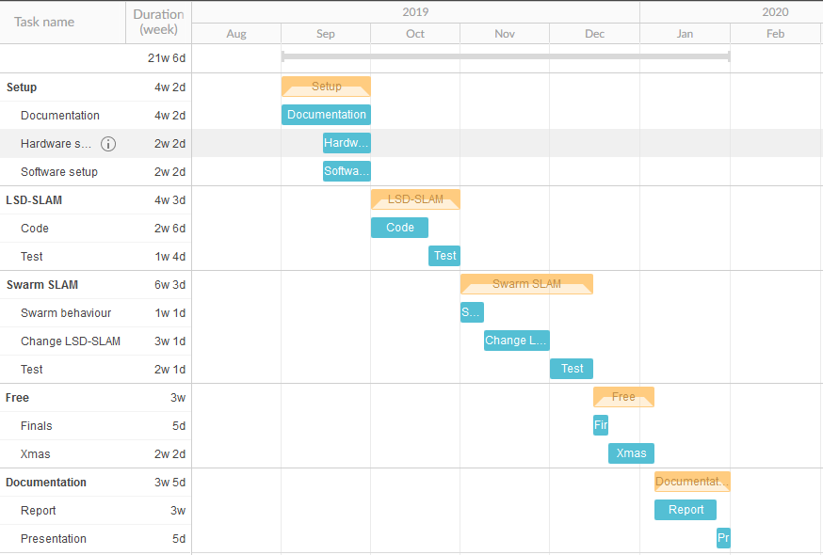

Problem statement: *(single sentence describing the overall challenge faced by the student)*  
Designing and implementing a SLAM algorithm on a swarm of monocular drones, using several moving cameras of unknown positions.

Research questions: *(provide two to five research questions of a single sentence that by answering them, jointly provide a path for addressing the problem statement)*

1. How effective are modern monocular SLAM techniques on a quadcopter?
2. Can we extend on these techniques when considering a swarm of quadcopters?
3. How do both options compare?
4. (optional)?
5. (optional)?

# End terms for specialized knowledge

For both master programs there are different end terms for specialized knowledge:

|  |  |
| --- | --- |
| Master Artificial Intelligence | Master Data Science for Decision Making |
| Objective area (Article 3.2a of the EER)   * Artificial Intelligence | Objective areas (Article 3.2b of the EER)   * Data Science * Applied Mathematics * Operations research |

The student is in the master:  
 Artificial Intelligence  
 Data Science for Decision Making

And the thesis topic relates to the end terms of the program as follows:  
Autonomous robotics is a major branch of Artificial Intelligence nowadays. More specifically to this project, location and mapping require intelligent algorithms capable of detecting and understanding the world around the robot. This is usually done using cameras, which means Computer Vision will also be part of the project. Furthermore, as we will be working on swarm robotics, we will need to program intelligent collective behaviour into the drones.

# Previous work

The student did not do an internship in the elective semester, nor intends to do so  
 The student did or intends to do an internship in the elective semester  
 If so,  
 Internship organization: ABB  
 Internship topic: Electric switchgear failure detection based on infrared images  
 Status of the internship: Finished

# Signature

The student would like to make the following additional statements to the board of examiners regarding this thesis plan:  
-

Ensure that you: *(Ensure that you check all)*

are familiar with the Education and Examination Regulations (EER) that are published on student portal, as is expected of each student

are familiar with the Rules and Regulations that are published on student portal, as is expected of each student

are familiar with the concept of plagiarism and will refrain from committing it

are aware of academic standards, in particular relating to proper citing

have filled out the complete form

have included a planning and/or attached a Gantt chart with a planning for your thesis

have collected the signatures of both examiners and if applicable, the external institute

have obtained 60 ECTS overall, of which 40 ECTS in year 1 of your master programme already; and have attached a transcript of your grades

Date: 12 September 2019

Student’s signature ………………………………………………..